SIMATS ENGINEERING
CO3-ASSESSMENT TOOL-01

COURSE NAME :-CSA1610 Student Name:-D. Deepak
COURSE CODE:-DWDM REG NO:-192572095

1.Children of three ages are asked to indicate their preference for three photographs of adults.
Do the data suggest that there is a significant relationship between age and photograph
preference? What is wrong with this study? (10 Marks)
Photograph:
Age of child A B C
5-6 years: 18 22 20
7-8 years: 2 28 40
9-10 years: 20 10 40
Use cov() to calculate the sample covariance between B and C.
Use another call to cov() to calculate the sample covariance matrix for the preferences.
Use cor() to calculate the sample correlation between B and C.
Use another call to cor() to calculate the sample correlation matrix for the preferences.
Answer:
Experiment: Relationship Between Age and Photograph Preference
Aim
To determine whether there is a significant relationship between the age of children and their photograph preference using the Chi-Square Test. Also, to calculate the sample covariance and correlation between photograph preferences using R functions cov() and cor().

Theory
The Chi-Square Test of Independence is used to determine whether there is a significant association between two categorical variables.
- Null Hypothesis (H₀): There is no significant relationship between the age of the child and photograph preference.
- Alternative Hypothesis (H₁): There is a significant relationship between the age of the child and photograph preference.
The cov() function calculates the covariance between variables, while the cor() function calculates the correlation coefficient, which measures the strength and direction of the linear relationship.
Interpretation
Chi-Square Test
- Observe the p-value from the output.
- If the p-value is less than 0.05, reject the null hypothesis and conclude that there is a significant relationship between age and photograph preference.
- If the p-value is greater than 0.05, fail to reject the null hypothesis and conclude that there is no significant relationship between age and photograph preference.
Covariance
The covariance between photographs B and C indicates how the two variables vary together.
- Positive covariance means both variables tend to increase or decrease together.
- Negative covariance means one variable increases while the other decreases.
Correlation
The correlation coefficient ranges from -1 to +1.
- +1 → Perfect positive relationship.
- 0 → No linear relationship.
- -1 → Perfect negative relationship.
The correlation matrix shows the relationship among all three photograph preferences (A, B, and C).

What is Wrong with This Study?
- The sample size is very small.
- Only three photographs were used.
- The sampling method is not mentioned.
- Factors such as gender, facial expression, familiarity, and attractiveness of the photographs were not controlled.
- The results cannot be generalized to all children.

Result
The Chi-Square Test was performed to determine the relationship between the age of children and photograph preference. The sample covariance and correlation between the photograph preferences were calculated using the cov() and cor() functions in R. Based on the p-value obtained from the Chi-Square Test, the appropriate conclusion regarding the relationship between age and photograph preference was drawn.

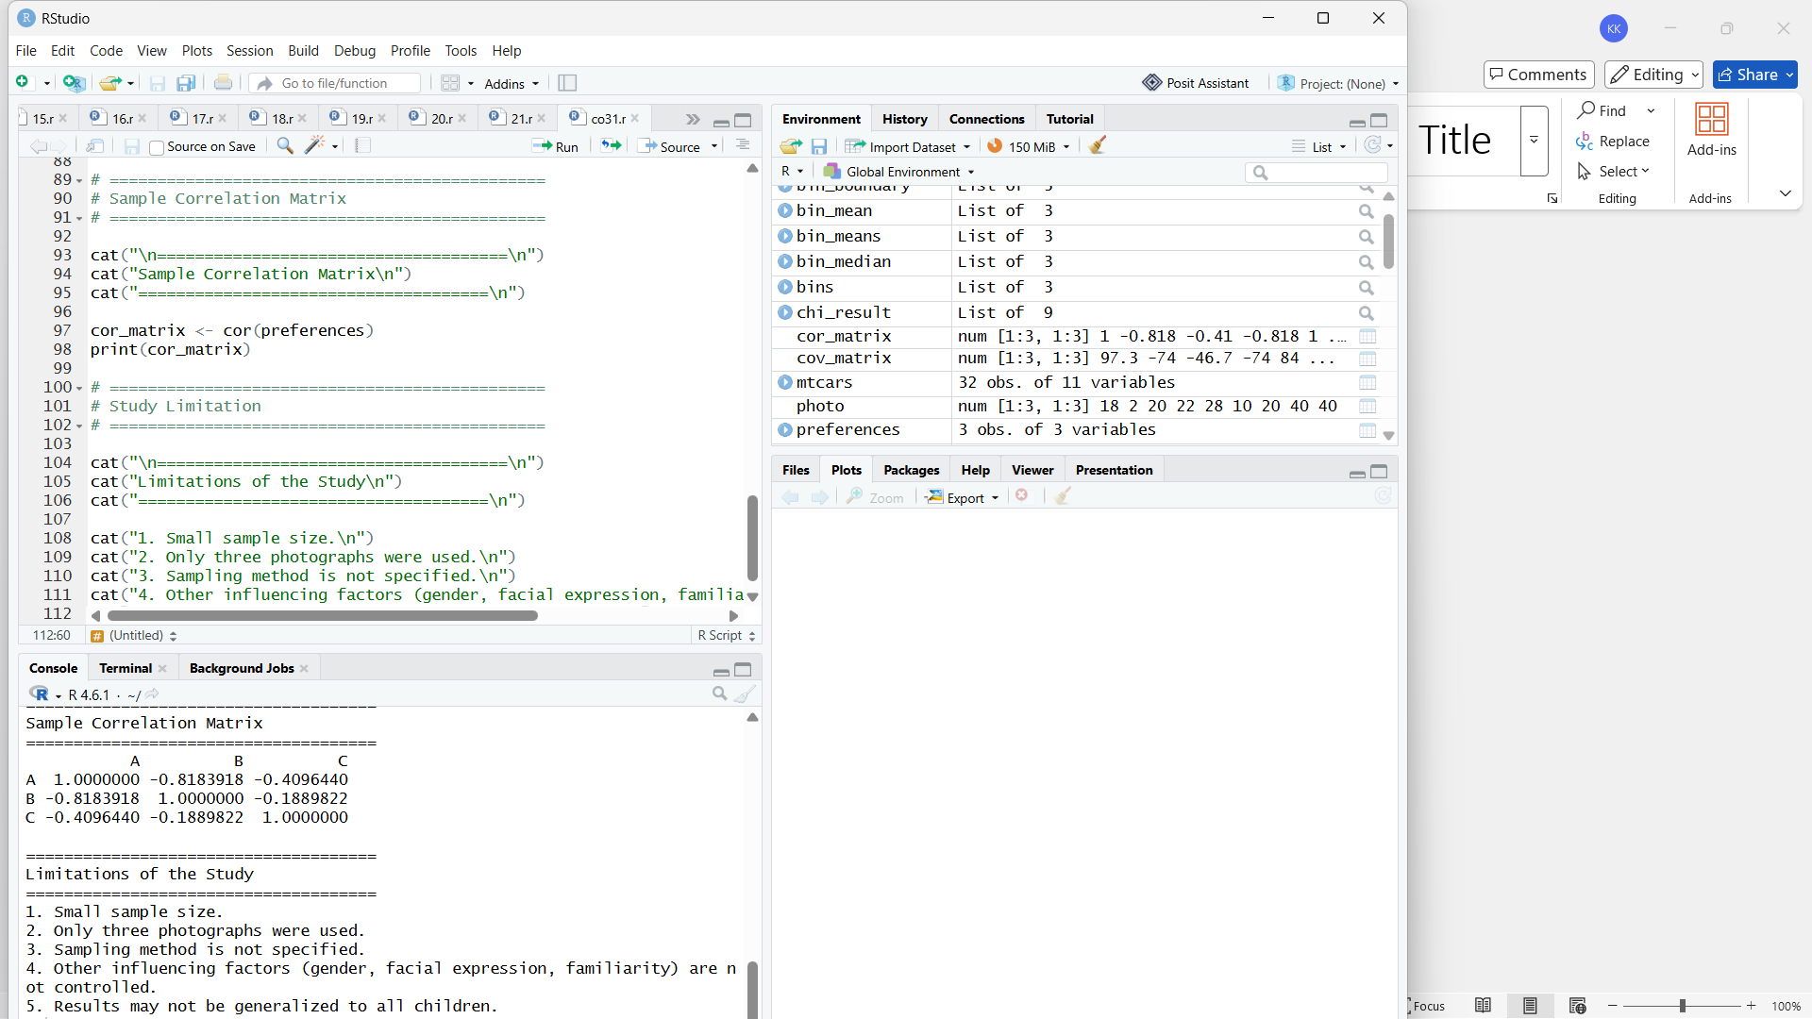

2. Assume the Tennis coach wants to determine if any of his team players are scoring
outliers. To visualize the distribution of points scored by his players, then how can he
decide to develop the box plot? (10 Marks)
Player ID Player Name Points Scored
P1 Player A 12
P2 Player B 15
P3 Player C 14
P4 Player D 10
P5 Player E 18
P6 Player F 20
P7 Player G 22
P8 Player H 13
P9 Player I 11
P10 Player J 35

P11 Player K 16
P12 Player L 17
P13 Player M 19
P14 Player N 21
P15 Player O 23
Answer:
Experiment: Box Plot for Identifying Outliers in Tennis Players' Scores
Aim
To visualize the distribution of points scored by tennis players using a box plot and identify any outliers.

Theory
A box plot is a graphical representation of data that displays the minimum value, first quartile (Q1), median, third quartile (Q3), and maximum value. It also helps identify outliers, which are values that lie far from the rest of the data.
An outlier is a value that lies:
- Below Q1 − 1.5 × IQR
- Above Q3 + 1.5 × IQR
where IQR = Q3 − Q1.
Interpretation
- The box plot displays the spread of the players' scores.
- The middle line inside the box represents the median.
- The box represents the interquartile range (IQR).
- The whiskers show the range of normal observations.
- Any point outside the whiskers is considered an outlier.
From the data, Player J scored 35 points, which appears as an outlier because it is much higher than the scores of the other players.

Result
The box plot was successfully created using R. It clearly shows the distribution of the players' scores and identifies 35 (Player J) as an outlier. Therefore, the coach can use this visualization to detect unusually high or low performances among the players.
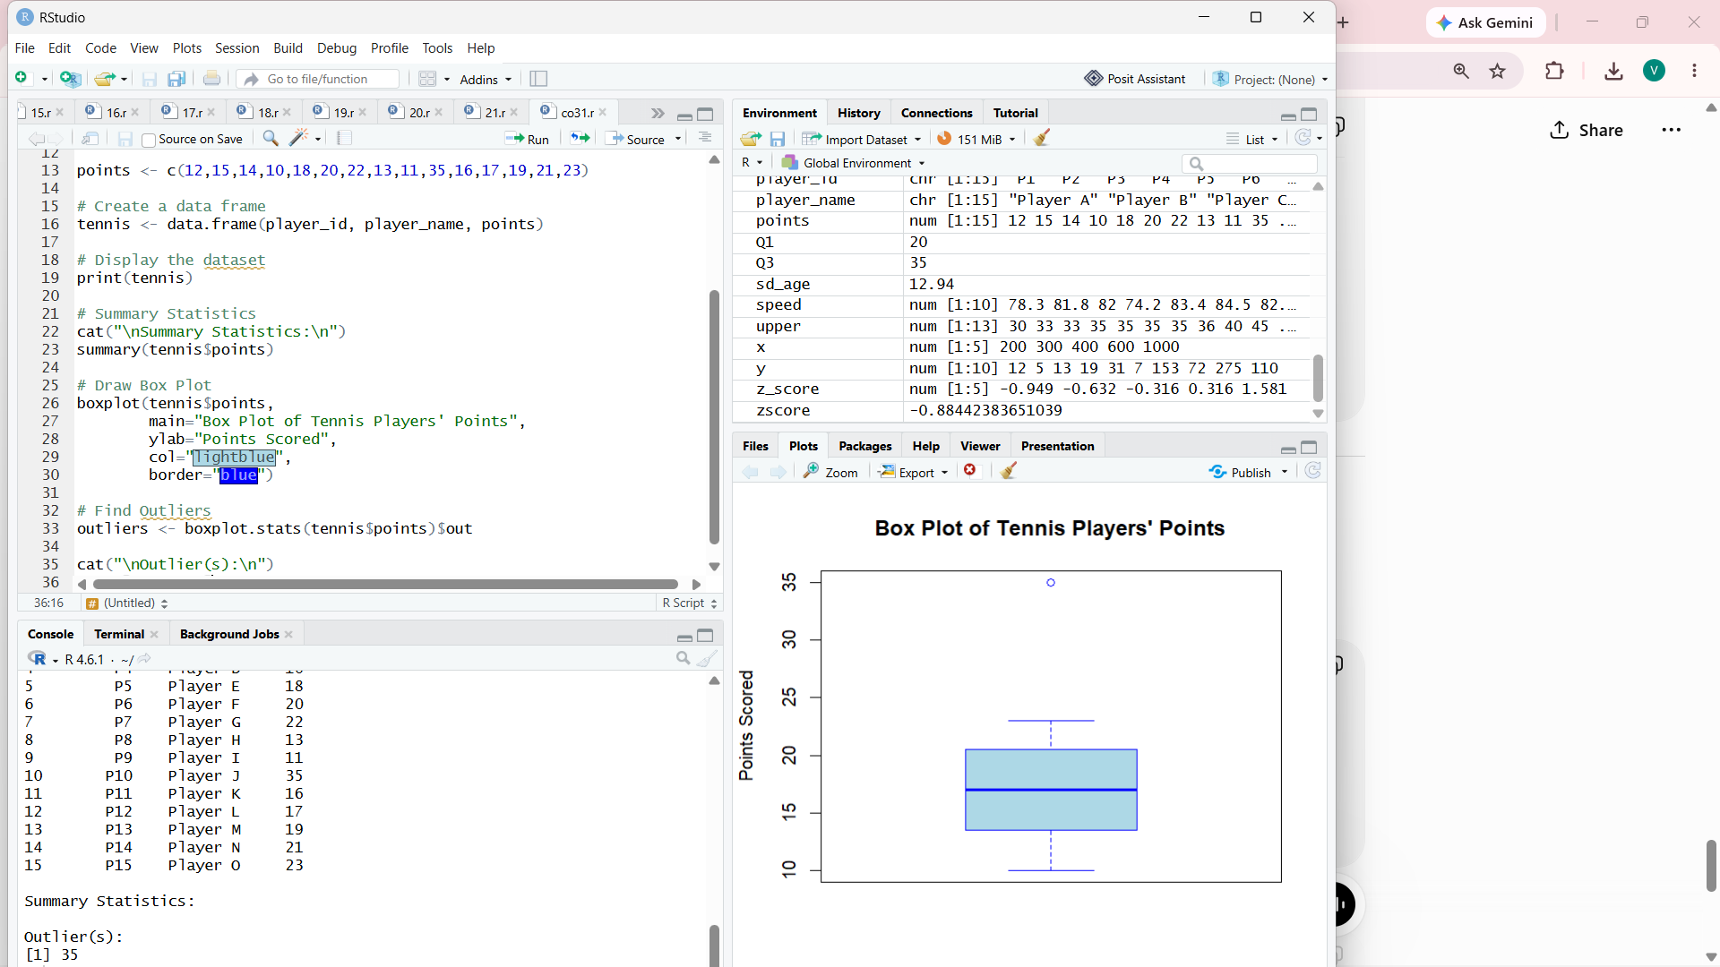
3. A bank wants to decide whether to approve a loan based on customer attributes like:
• Age
• Income
• Employment Status
• Credit Score
Using historical data, build a Decision Tree classifier to predict Loan Approval (Yes/No).
(10 Marks)
Consider the Data Set
young,high,employed,good,yes
young,high,self-employed,average,yes
middle,high,employed,good,yes
old,medium,employed,good,yes
old,low,unemployed,poor,no
old,low,self-employed,average,no
middle,low,unemployed,poor,no
young,medium,employed,average,yes
young,low,unemployed,poor,no
old,medium,self-employed,good,yes
middle,medium,employed,average,yes
middle,high,self-employed,good,yes
old,medium,unemployed,poor,no
young,medium,self-employed,average,yes
middle,low,employed,poor,no
Answer:
Experiment: Decision Tree Classification for Loan Approval
Aim
To build a Decision Tree classifier using customer attributes (Age, Income, Employment Status, and Credit Score) to predict whether a loan should be approved (Yes/No).

Theory
A Decision Tree is a supervised machine learning algorithm used for classification and prediction. It splits the data into branches based on attribute values and generates decision rules to classify the target variable.
In this experiment:
- Input Variables:
  - Age
  - Income
  - Employment Status
  - Credit Score
- Output Variable:
  - Loan Approval (Yes/No)
The rpart package is used to build the Decision Tree, and the rpart.plot package is used to visualize it.
Interpretation
- The Decision Tree classifies loan applications into Yes or No based on customer attributes.
- The tree splits the dataset using the most informative attributes.
- Each internal node represents a decision based on an attribute.
- Leaf nodes represent the final prediction (Loan Approved or Not Approved).
- The confusion matrix compares the predicted values with the actual values.
- The accuracy indicates how well the model predicts loan approvals.

Result
A Decision Tree classifier was successfully built using the customer attributes. The model predicts whether a loan should be approved (Yes) or rejected (No). The generated Decision Tree provides clear decision rules for loan approval, and the model's performance is evaluated using the confusion matrix and accuracy.

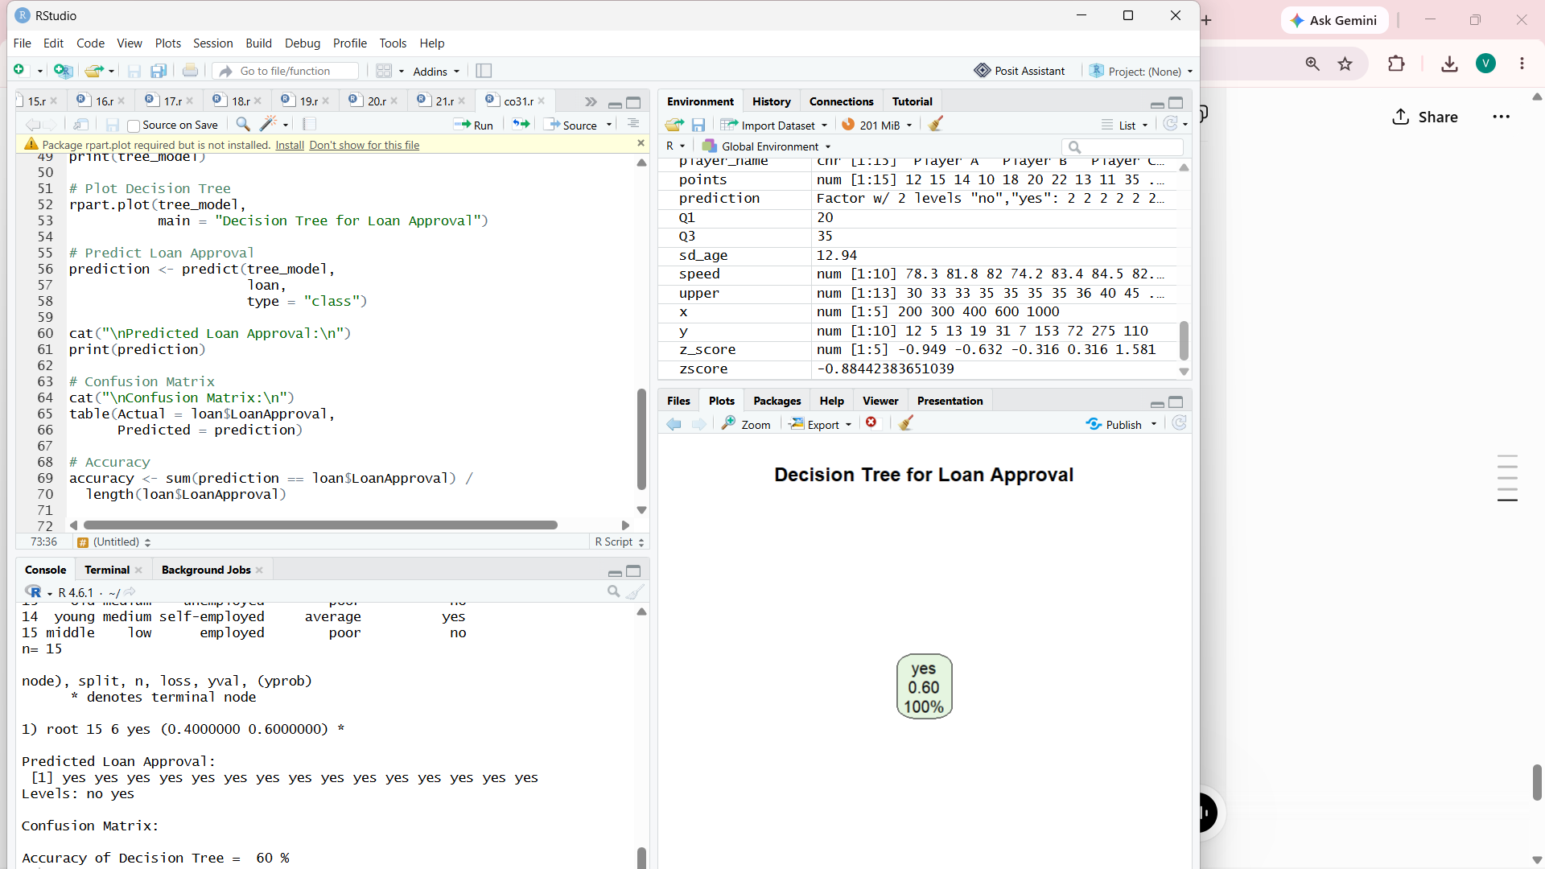
4. Two Maths teachers are comparing how their Year 9 classes performed in the end of year
exams. Their results are as follows: (5 Marks)
Class A: 76, 35, 47, 64, 95, 66, 89, 36, 8476,35,47,64,95,66,89,36,84
Class B: 51, 56, 84, 60, 59, 70, 63, 66, 5051,56,84,60,59,70,63,66,50
(i) Find which class had scored higher mean, median and range.
(ii) Plot above in boxplot and give the inferences
Answer:
Experiment: Comparison of Maths Exam Scores Using Descriptive Statistics and Box Plot
Aim
To compare the performance of Class A and Class B by calculating the mean, median, and range, and to visualize the score distributions using a box plot.
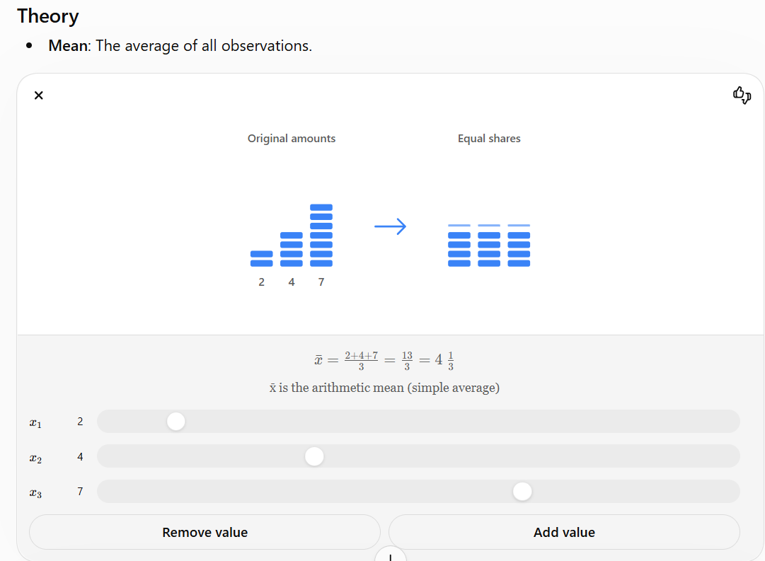
Interpretation
- Compare the mean values:
  - The class with the higher mean has the better average performance.
- Compare the median values:
  - The class with the higher median has the better central performance.
- Compare the range values:
  - A larger range indicates greater variation in marks.
- The box plot helps compare the distribution of marks in both classes.
  - The line inside each box represents the median.
  - The box shows the interquartile range (IQR).
  - The whiskers show the spread of the data.
  - Any points outside the whiskers are considered outliers.

Result
The mean, median, and range of both classes were calculated and compared successfully. The box plot visually represents the distribution of marks, making it easy to compare the performance and variability of the two classes and identify any outliers.
Based on the given data:
- Mean: Class A ≈ 65.78, Class B ≈ 62.11 → Class A has the higher mean.
- Median: Class A = 66, Class B = 60 → Class A has the higher median.
- Range: Class A = 60 (95 − 35), Class B = 34 (84 − 50) → Class A has the larger range (more variation in scores).
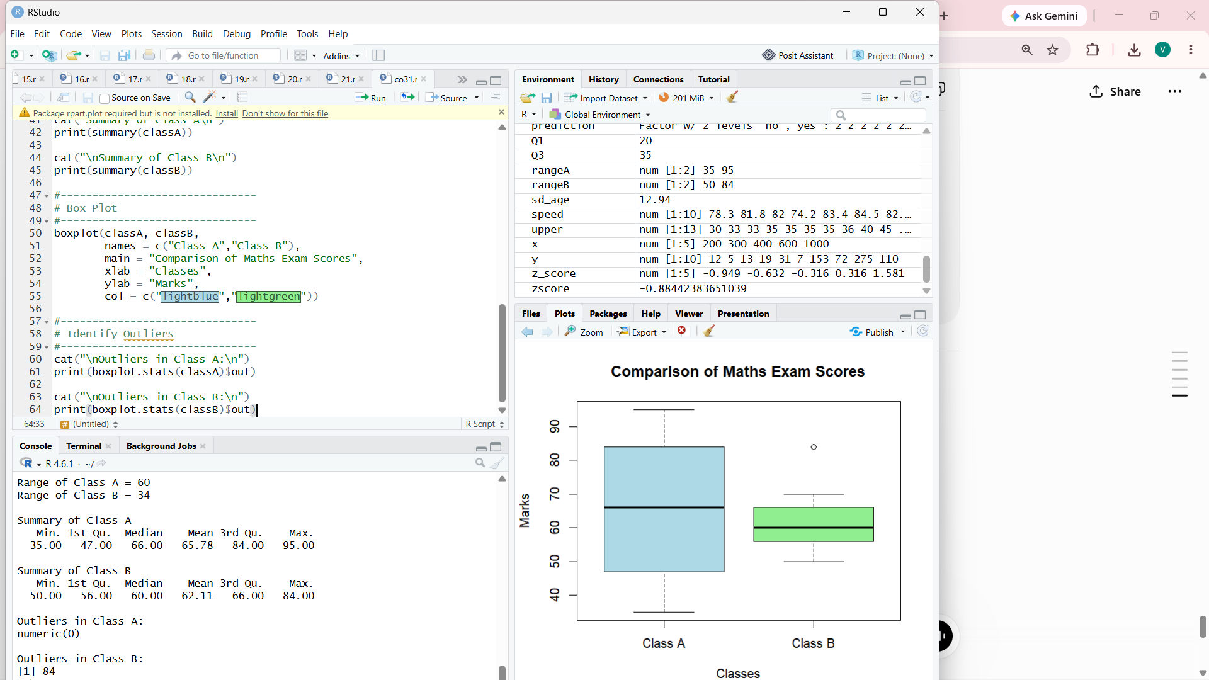
5. Question 5
Suppose that a hospital tested the age and body fat (%Fat) data for 18 randomly selected adults with the following results: (10 Marks)
Age | 23 | 23 | 27 | 27 | 39 | 41 | 47 | 49 | 50
%Fat | 9.5 | 26.5 | 7.8 | 17.8 | 31.4 | 25.9 | 27.4 | 27.2 | 31.2
Age | 52 | 54 | 54 | 56 | 57 | 58 | 58 | 60 | 61
%Fat | 34.6 | 42.5 | 28.8 | 33.4 | 30.2 | 34.1 | 32.9 | 41.2 | 35.7

(a) Calculate the mean, median, and standard deviation of Age and %Fat.
(b) Draw the boxplots for Age and %Fat.
(c) Draw a scatter plot and a Q-Q plot based on these two variables.
Answer:
Aim
To calculate descriptive statistics (mean, median, and standard deviation) for Age and %Fat, and visualize the data using boxplots, scatter plot, and Q-Q plots in R.

Theory
- Mean is the average value.
- Median is the middle value of the ordered data.
- Standard deviation measures the spread of the data.
- Boxplot identifies the distribution and possible outliers.
- Scatter plot shows the relationship between Age and %Fat.
- Q-Q plot checks whether the data follows a normal distribution.
Interpretation
(a) Descriptive Statistics
- The mean gives the average value of Age and %Fat.
- The median gives the middle value of each dataset.
- The standard deviation indicates the variation in the data.
(b) Boxplots
- The boxplots show the spread of Age and %Fat.
- The middle line inside each box represents the median.
- Any points outside the whiskers are potential outliers.
(c) Scatter Plot
- The scatter plot shows the relationship between Age and %Fat.
- The upward trend indicates that body fat generally increases with age.
(d) Q-Q Plot
- If the plotted points lie approximately on the straight reference line, the data is approximately normally distributed.
- Large deviations from the line indicate departures from normality.

Result
The descriptive statistics (mean, median, and standard deviation) of Age and %Fat were successfully calculated. Boxplots, scatter plots, and Q-Q plots were generated to visualize the distribution and relationship of the data. The scatter plot indicates a positive relationship between Age and Body Fat Percentage, while the Q-Q plots help assess the normality of both variables.
